Nuance® PowerShare™ Network
Using the Easy Uploader

For the best experience, it is recommended to use either the Chrome, Firefox, or Microsoft Edge browser.  Navigate to the Easy Uploader using the URL you received from your hospital.  Note: There might be unique instructions provided by your hospital. If so, it will be on the left side of your screen in Blue. | 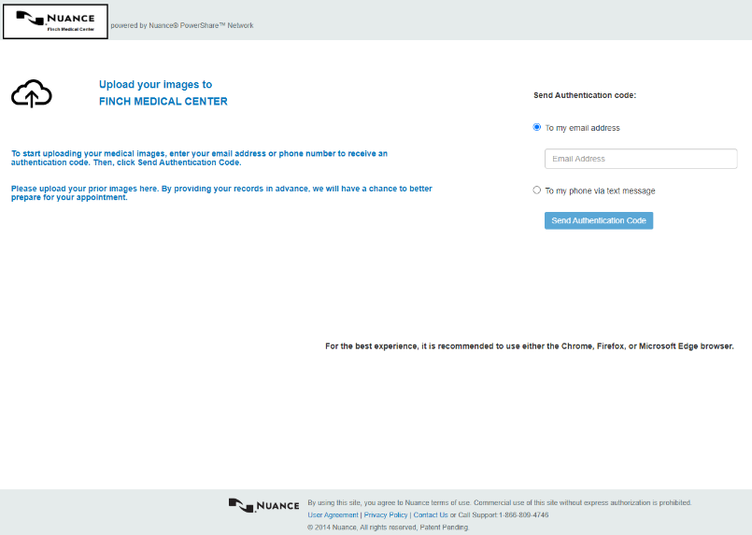
Before uploading, you need to request an Authentication Code by providing either your email address or your phone number.

Once you receive the code, provide the code on the following screen.  Note: Your authentication code expires in 5 minutes.  Check the box to agree to the Terms and Conditions and the HIPAA Agreement.  Click Confirm Authentication Code. | 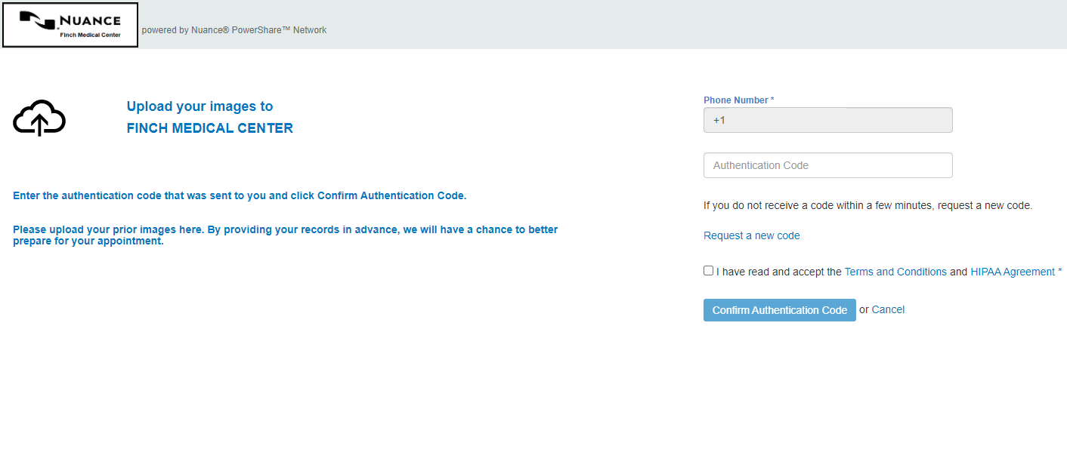
The uploader will open in the same window.  Click the Choose Folder button and select the CD or directory containing the files you wish to upload.  Click Upload if applicable. | 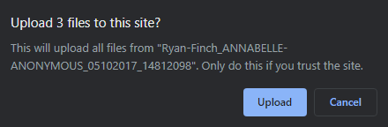
Click the Upload button. | 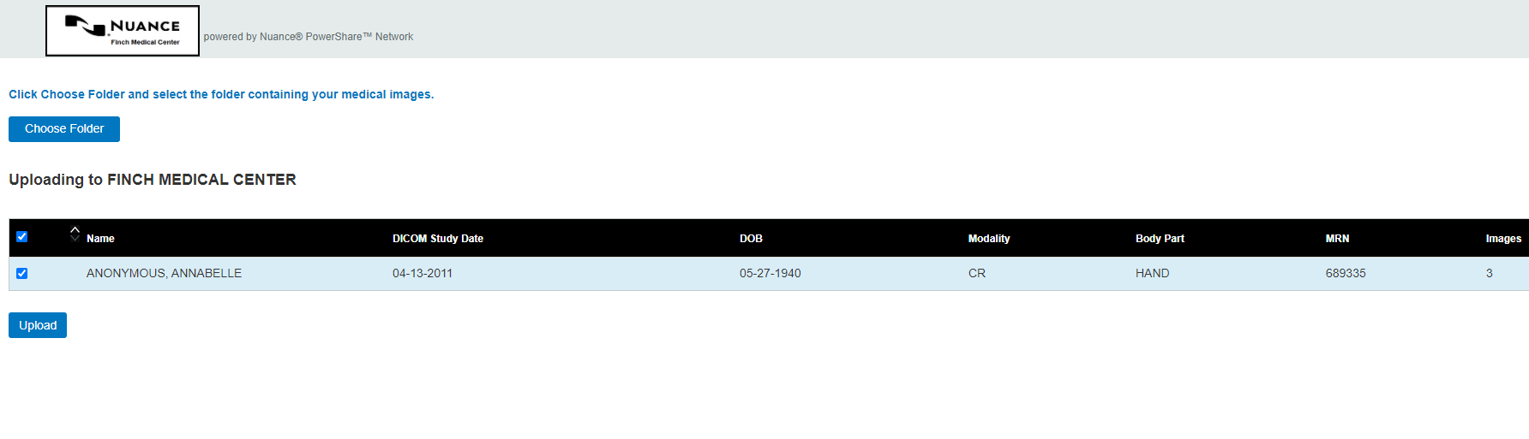
You will receive a Transfer Complete notice in the progress bar.  Note: There might be unique post upload instructions provided by your hospital. If so, it will be on the top left side of your screen in Blue.  You can now close the screen or click upload another to repeat the upload process. | 